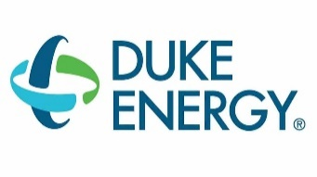
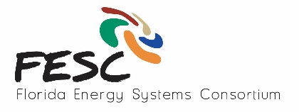

State of the Union on Florida Energy

March 23, 2016

University of Florida, Gainesville FL – Reitz Union, Chamber Room

Agenda

9:00 to 10:00am: Registration
10:00 am: Welcome and FESC Overview, Dr. David Norton, FESC Director, VP of Research, UF
10:15 am: The State of Energy in Florida, Buck Martinez, Sr. Director Office of Clean Energy, FP&L, Chair of FESC Advisory Board
10:40 am: Florida’s Energy Future, Amy Stein, Associate Professor of Law, UF
11:00 am PANEL SESSION I: Smart Grid and Integration of Renewables (10 min presentations followed by a panel discussion) – Moderator: Buck Martinez
Energy interests at Duke Energy, Tom Lawery, Wholesale Renewables Manager, Distributed Energy Resources, Duke Energy, FESC Advisory Board Member
Smart Grid Cyber-Physical Security: An Innovation Approach, Dr. Arturo Bretas, ECE, UF
Grid Security, Dr. Mark Tehranipoor, ECE, UF
IBM Cloud/Smart Grid Efforts, Michael Weinberg, and Vivian A Boykin, IBM Bluemix
Getting the Incentives Right for Renewables, Ted Kury, Director of Energy Studies, UF
12:30 – 1:30 pm Lunch – Sponsored by FP&L and Duke Energy
1:30 – 3:00 pm: PANEL SESSION II: New and Exciting technologies (15 min presentations followed by a panel discussion) – Moderator: Sean Meyn
Indo-US Joint Clean Energy R & D Center, Dr. Wilfred Vermerris, Micro. & Cell Science, UF
Marine Energy: Hydrokinetic Power, Camille Coley, Assistant Vice President for Research, FAU
High Temperature H₂ Production and Storage and Energy Initiatives at UF Energy Park, Dr. Jonathan Scheffe, Mechanical and Aerospace Engineering, UF
Siemens Wind Power and Renewables Division, Lanny Kirkpatrick, Technology Manager, Siemens Wind
3:00 pm – Meeting Adjourns

