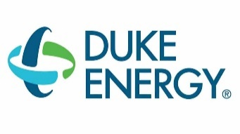
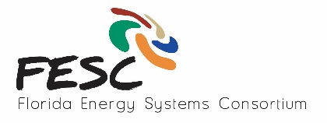
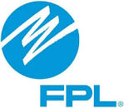
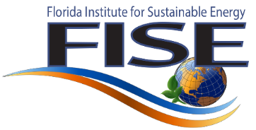

State of the Union on Florida Energy

March 23, 2016

Speaker Bio’s

Dr. David Norton, FESC Director, VP of Research, UF
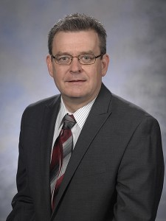
David P. Norton, Ph.D., became Vice President for research at the University of Florida in January 2012. He had served as associate dean for research in the UF College of Engineering since 2009. He is also a professor in the Department of Materials Science and Engineering.
Dr. Norton came to UF in 2000 after 11 years at Oak Ridge National Laboratory. His research interests primarily focus on electronic, photonic and magnetic thin film materials. He has published more than 300 articles in refereed journals and books, presented numerous invited papers and lectures at national and international conferences, and organized conferences and workshops in the areas of electronic oxides and laser processing. He is a Fellow of the American Vacuum Society, the American Physical Society and the American Association for the Advancement of Science, and a member of the Materials Research Society and the Electrochemical Society.
Dr. Norton conducted his undergraduate and graduate studies within the Department of Electrical and Computer Engineering at Louisiana State University, receiving his doctorate in 1989.

Buck Martinez, Sr. Director Office of Clean Energy, FP&L, Chair of FESC Advisory Board
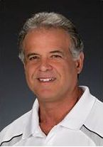
J.L. Martinez oversees the Office of Clean Energy at FP&L, a subsidiary of NextEra Energy, where his responsibilities include identifying and originating clean energy opportunities in the state to promote visibility, commitment, and economic development. Most recently, Mr. Martinez led the Company’s efforts in the development of three large solar projects and three large combined cycle natural gas facilities. NextEra Energy is one of the nation’s leading electricity-related services companies. Its subsidiaries include Florida Power & Light Company, Florida’s largest electric utility with nearly 4.6 million customer accounts, and NextEra Energy Resources, a fast-growing independent power producer with a presence in 26 states.
Mr. Martinez joined Florida Power & Light in 1981. Prior to being named to his present position, he served as Senior Director of Project Development in the state. Before that he served as Director of Human Resource Services overseeing the corporate safety department, labor relations, and the corporate quality program. He has also served the company in various management positions and special projects.
Mr. Martinez holds a Bachelor of Arts degree from St. Thomas University and a Master of Business Administration degree from Nova Southeast. In addition, he is a graduate of the Boston University Leadership Program., and the Harvard Program on Negotiation. Most recently, Mr. Martinez was elected to the St. Thomas University Hall of Fame. Mr. Martinez serves as the Chairman of the Florida Solar Energy Center and also serves on other Advisory Boards throughout the State, most notably The Florida Energy Systems Consortium, The Florida Research Consortium (FRC), and The St. Thomas University President’s Advisory Board. He has also worked closely with the Department of Energy on renewable energy initiatives and is active in speaking engagements throughout the country. Mr. Martinez is also on the West Palm Board of the Fellowship of Christian Athletes and recently founded Student Aces (ACE), a not for profit organization dedicated to the development of leadership for high school students. He and his wife Silvia, their three children and four grandchildren, live in Palm Beach Gardens, Florida.

Amy Stein, Professor, Levin College of Law, University of Florida
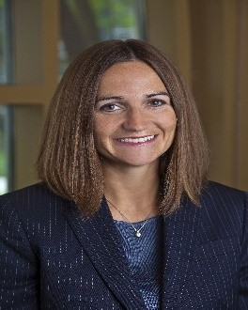
Professor Stein focuses her scholarship on clean energy law, electric grid governance, distributed energy resources and reliability, environmental law, and federalism. Her recent publications urge regulatory reforms to better harness the reliability benefits of customer-owned reliability resources (demand response and energy storage) for the public grid, address the implications of the regulatory uncertainty surrounding energy storage, assess the federal government's role in developing renewable energy, and analyze the federalism implications of subnational control over siting of electricity generation, all of which can be accessed at http://ssrn.com/author=1216973. Her current research explores the historic, economic, and environmental implications of regulating electric grid reliability in an era of new reliability resources like energy storage and demand response and new rules like the Clean Power Plan. Her current works in progress separately address the growing importance of state action impacting reliability of the bulk electric grid and mechanisms to break the path dependencies associated with energy decision-making.
Professor Stein is a nationally recognized authority on reliability of the electric grid, energy storage, and energy jurisdiction. She has presented her energy work across the country, in both academic and policy forums, as well as in Costa Rica and an upcoming conference in Cuba. Her work has been selected for presentation twice for presentation at Columbia Law School’s Sabin Colloquium on Innovative Environmental Law Scholarship, as well as for presentation at Minnesota Law School's Legal and Policy Pathways for Energy Innovation conference, University of Texas’s Austin Electricity Conference, Northwestern's Searle Center Conference on Electricity Regulation, and the Electric Power Executive Conference. She has delivered the plenary presentation at the 21st Annual University of Florida Public Interest Conference, the keynote at the Florida Energy Systems Consortium’s annual conference, and numerous presentations in Washington, D.C., including the annual University Advisory Board seminar on Reliability and the North American Grid to state senators and representatives from the top energy-producing states, and a congressional staffer briefing on transmission. Professor Stein began her academic career at George Washington University Law School and Tulane Law School. Prior to her academic appointments, she practiced as an environmental and litigation associate for Latham & Watkins LLP in the firm's Washington, D.C., and Silicon Valley offices. She is a member of the District of Columbia, Illinois, and California state bars. She is a graduate of the University of Chicago (AB) and the University of Chicago Law School (JD).

Tom Lawery, Wholesale Renewables Manager, Distributed Energy Resources, Duke Energy, FESC Advisory Board Member
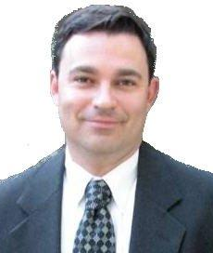
Thomas Lawery advances renewable, qualifying facility and distributed energy resource business for both utility-owned and non-utility owned distributed generation in Florida.
Mr. Lawery has worked for 26 years in the power industry for Florida Power then Progress Energy and presently Duke Energy, the largest regulated utility in the United States. Prior to his present role as Wholesale and Renewables manager, Mr. Lawery most recently held the position of Director of Business Planning overseeing $1B in power plant capital asset management across all of Duke’s regulated generation plants.
Previous roles included Director of Outage and Maintenance Services providing power plant outage and maintenance support for the 57 plants throughout Florida. He has also held positions in power plant management and operations, project, engineering and construction management and environmental support.
Mr. Lawery holds a bachelor’s degree in Electrical Engineering from Florida State University and is a licensed Professional Engineer in the State of Florida. Mr. Lawery also earned his master’s degree in business administration (MBA) from the University of Tampa.

Dr. Arturo Bretas, Electrical and Computer Engineering (ECE), UF
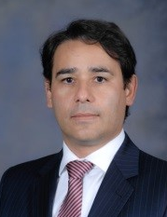
Arturo Bretas is a Professor at the Department of Electrical and Computer Engineering at the University of Florida and the director of the Power Systems Laboratory. His research interests include Power Systems Operation, Protection, Control, Reliability Optimization and Restoration, Power Quality, Distribution Systems Automation and Operation, Power and Distribution Systems State Estimation, and Power Systems Dynamics.

He has held visiting positions at universities all over the world, including the Institute National Polytechnique de Grenoble, Grenoble France during 2003-2004 where he was a CNRS Scholar. Since 2002, he has been involved as a PI/CPI on more than 15 industrial projects totalizing $21 Million in funding. These projects are in the areas of power system security, new technologies to enhance power system control and monitoring, distribution systems reliability optimization and planning under deregulation. Dr. Bretas has published over 175 scientific and conference papers in international conferences and journals.

Dr. Mark Tehranipoor, Electrical and Computer Engineering (ECE), UF
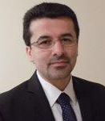
Mark Tehranipoor is currently the Intel Charles E. Young Preeminence Endowed Professor in Cybersecurity at the ECE Department, University of Florida. His current research interests include: hardware security and trust, supply chain risk management and security, counterfeit electronics detection and prevention and reliable circuit design. Dr. Tehranipoor has published over 300 journal articles and refereed conference papers and has given more than 150 invited talks and keynote addresses since 2006. He has two patents, and has published six books and eleven book chapters. He is a recipient of 12 best paper awards and nominations, as well as the 2008 IEEE Computer Society (CS) Meritorious Service Award, the 2012 IEEE CS Outstanding Contribution, the 2009 NSF CAREER Award, and the 2014 MURI award. His projects are sponsored by both the industry (Semiconductor Research Corporation (SRC), Texas Instruments, Freescale, Comcast, Honeywell, LSI, Avago, Mentor Graphics, R3Logic, Cisco, Qualcomm, MediaTeck, etc.) and Government (NSF, ARO, MDA, DOD, AFOSR, DOE, etc.).
He serves on the program committee of more than a dozen leading conferences and workshops. He served as Program and General Chairs of several leading conferences and workshops. Prior to joining UF, Dr. Tehranipoor was the founding director of the Center for Hardware Assurance, Security, and Engineering (CHASE) and the Comcast Center of Excellence in Security Innovation (CSI) at the University of Connecticut. He co-founded a new symposium called IEEE International Symposium on Hardware-Oriented Security and Trust (HOST) and served as HOST-2008 and HOST-2009 General Chair. He is currently serving as HOST’s Chair of Steering Committee. He is also the co- founder of Trust-Hub (www.trust-hub.org). He served as an Associate EIC for IEEE Design & Test, an IEEE Distinguished Speaker, and an ACM Distinguished Speaker from 2010 to 2014. He is currently serving as an Associate Editor for JETTA, JOLPE, Transactions on VLSI (TVLSI), and Transactions on Design Automation for Electronic Systems (TODAES). Dr. Tehranipoor is a Senior Member and Golden Core Member of the IEEE and Member of ACM and ACM SIGDA.

Michael Weinberg, Technical Sales Professional, IBM Bluemix
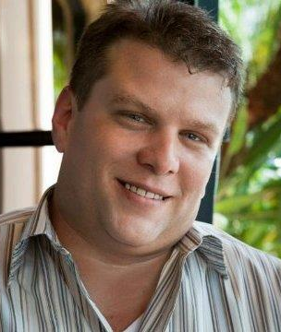
Michael Weinberg is with Bluemix Sales at IBM located at Boca Raton.
He is a Sales Executive and Manager with over 15 years of experience in outside business to business technical sales, inside sales and sales management with broad achievement developing new and/or under-performing territories, as well as building highly successful sales teams. He utilizes Large Account Management Process and other consistent sales methodologies to meet the team goals.

Prior to joining IBM Bluemix team, he was a Managing Partner with Skana Systems.

Vivian A Boykin, Bluemix Technical Sales Professional at IBM
Vivian is a Developer, Designer, and a Dreamer. She is a visionary, using her technical skills to make the world an interactive, connected and user-friendly place. A leader by nature, she strive to combine her ability to efficiently communicate ideas with her experience in development and thought leadership to help clients fully realize their potential within the cloud space and embrace the art of the possible to drive disruption. Using the latest technologies to create fully realized immersive experiences that help people see the world around them in a new way; striving daily for innovation through challenges; seeking Inspiration from unlikely sources, and never settling.

Ted Kury, Director of Energy Studies, UF
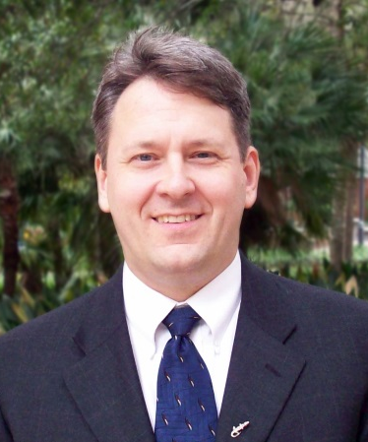
Ted Kury is director of Energy Studies for the Public Utility Research Center (PURC) at the University of Florida. He is responsible for promoting research and outreach activities in energy regulation and policy. He has worked with regulatory and utility professionals on six continents and his research has been featured on CNN, Fox News, NPR, and the Wall Street Journal. He holds a Ph.D. in Economics from the University of Florida

Dr. Wilfred Vermerris, Associate Professor, Department of Microbiology and Cell Science, UF
Dr. Wilfred Vermerris is Associate Professor of Microbiology & Cell Science at the University of Florida where he conducts research on the genetic improvement of sorghum for the production of renewable fuels and chemicals, and on the development of nanomaterials from biorefinery residues. He and his team use genetic approaches to not only improve the performance and yield of the crop, but also the bioprocessing characteristics and properties of the materials that can be produced from plant biomass. He has degrees in biomolecular engineering and genetics. He is the principal investigator of two multimillion dollar research grants from the US Department of Energy and the US Department of Agriculture and is Co-Editor-in-Chief of the journal BioEnergy Research. He is leading the Indo-US Joint Clean Energy Research & Development Center.

Dr. Vermerris is a member of the University of Florida Genetics Institute, and participates in the Genetics & Genomics graduate program and the Plant Molecular & Cellular Biology Graduate Program. He has adjunct appointments in the department of Materials Science & Engineering at UF and the department of Agricultural & Biological Engineering and the Laboratory of Renewable Resources Engineering at Purdue University. He is the co-author of the textbook ‘Phenolic Compound Biochemistry‘, editor of the book ‘Genetic Improvement of Bioenergy Crops’ and Co-Editor-in-Chief of the journal BioEnergy Research.

Camille Coley, Assistant Vice President for Research, FAU
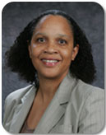
Camille E. Coley, J.D., serves as Assistant Vice President for Research and the Associate Director for the Southeast National Marine Renewable Energy Center at Florida Atlantic University (FAU). At FAU, Ms. Coley directs the Division of Research’s Program Development by overseeing the internal awards programs for researchers, holding workshops and seminars to support research activities, and engaging external sponsors. She is actively involved in the University Committee by serving as a liaison to the University Research Committee, the University Safety Committee, University Facilitates Committee and the Diving and Boating Safety Committee. She manages the regulatory activities of the Southeast National Marine Renewable Energy Center with federal, state and local governmental organizations as well as the Center’s outreach and education programs. Further, Ms. Coley was a member of the Governor’s 21-member Action Team on Energy and the Environment, and currently serves on the Federal Advisor Committee to the U.S. Global Climate Program.

Dr. Jonathan Scheffe, Associate Professor, Mechanical and Aerospace Engineering, UF
Jonathan Scheffe (Ph.D. University of Colorado, Boulder) joined the Mechanical and Aerospace Engineering Department at the University of Florida in September of 2014 after working for 4 years as a postdoctoral researcher and senior research associate in the Renewable Energy Carriers laboratory at ETH Zurich. Prof. Scheffe’s research is focused on the conversion and storage of solar energy in the form of renewable fuels/electricity through thermochemical and electrochemical routes. His background is in the fields of high temperature reactor design, solid state kinetics and thermodynamics. He serves on the executive committee of the ASME Solar Energy Division and organizing committee as Technical Chair of the ASME International Conference on Energy and Sustainability

Lanny Kirkpatrick, Technology Manager, Siemens Wind Power

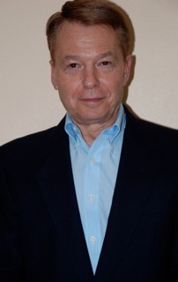
Mr. Lanny Kirkpatrick is a Technology Manager in Siemens Wind Power as part of Siemens Energy in Orlando, Florida. Siemens has been involved in numerous Department of Energy research and development programs as well as a participant in an ongoing CRADA (Cooperative Research and Development Agreement) with the National Wind Technology Center in Boulder Colorado.
His current responsibilities include managing Siemens proposal efforts in Department of Energy funding opportunities and university programs for Siemens Wind Power as well as coordinating technology screening for new ideas with external partners.
Lanny joined Westinghouse Electric Corp in 1976. The power generation business of Westinghouse was acquired in the late 90’s by Siemens. In addition to his role in wind power technology, he has held various sales and marketing positions in the United States and Latin America. He received a Bachelor of Science degree in Electrical Engineering from the University of Texas at Austin.

