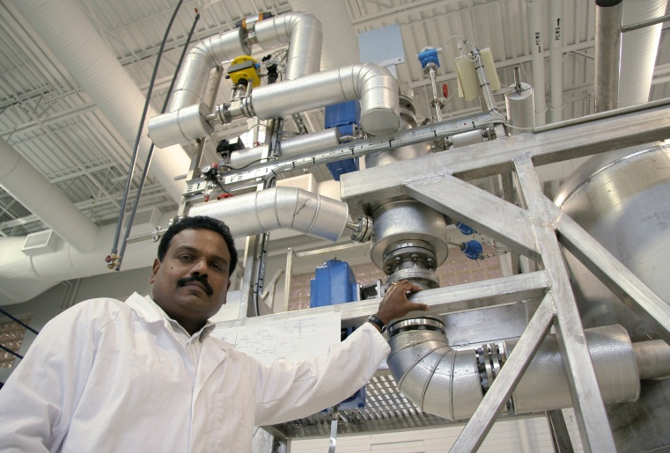
UF-led Research Team Selected for $125 Million Joint U.S.-India Energy Project

A University of Florida-led research team has been selected to participate in a five-year, $125 million energy project involving the United States and India, U.S. Department of Energy officials have announced.
Known as the Joint Clean Energy Research and Development Center, or JCERDC, the project is aimed at reducing energy consumption, cutting dependence on petroleum products and increasing use of renewable fuels.
The UF-led team will develop biofuels derived from inedible plant material. Two other research teams, led by the National Renewable Energy Laboratory and Lawrence Berkeley National Laboratory, will focus on solar energy and energy efficiency of buildings, respectively.
Total funding for the biofuels project is about $21 million, including about $2.7 million in federal funding destined for UF.
“This award highlights many of the attributes that make the University of Florida a world-class research institution,” said David Norton, UF vice president for research. “It illustrates our commitment to building interdisciplinary partnerships, both domestically and internationally, to achieve important scientific goals such as developing renewable clean-energy solutions.”

Also on the UF-led team are the University of Missouri, Virginia Tech, Montclair State University, Texas A&M University, Show Me Energy Cooperative, and Green Technologies. They will work with a counterpart team based in India and led by the Indian Institute of Chemical Technology-Hyderabad.
The researchers’ primary goal will be to develop and optimize several crops as biofuel feedstocks, said Pratap Pullammanappallil, an associate professor with UF’s Institute of Food and Agricultural Sciences. The crops include high-yield biomass sorghum, sweet sorghum, pearl millet, bamboo and switch grass.
Sorghum and switch grass will likely be the group’s initial focus, he said. The UF researchers will concentrate on improving technology for converting biomass to fuel. Much of the work will take place in the Biofuels Pilot Plant on the UF campus and the Stan Mayfield Biorefinery Pilot Plant in Perry, a joint venture between UF and Buckeye Technologies Inc.
“Another goal is to expand our capacity to utilize waste streams in the cellulosic ethanol conversion process,” he said. The researchers will investigate ways of using spent feedstocks, wastewater and other materials to produce additional bioenergy and products such as fertilizers and bioplastics.
Pullammanappallil, based at the agricultural and biological department, is the team’s principal investigator. Other UF faculty members on the team are: Zhaohui Tong of agricultural and biological engineering; Lonnie Ingram and Keelnatham Shanmugam of microbiology and cell science; Ramesh Reddy, George O’Connor and Ann Wilkie of soil and water science; and Wilfred Vermerris of agronomy.
Work on the project is expected to begin this fall, Pullammanappallil said.

