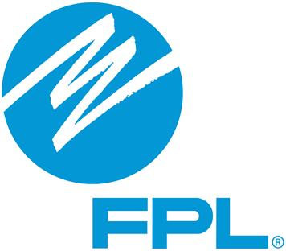
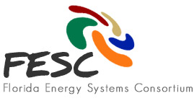
FESC Stakeholders Meeting
Attendee List
FPL Attendees
- Eric Silagy, President of FPL
- Claude Masters, FPL

FESC Attendees
- Jennifer Curtis, FESC
- Jim Fenton, FSEC/UCF
- Issa Batarseh, UCF
- Canan Balaban, FESC
- Yogi Goswami, USF
- Sue Skemp, FAU
- Camille Coley, FAU
- Ryan Integlia, Florida Polytechnic University
- Ghazi Darkazalli,Florida Polytechnic University
- Sean Meyn, UF
- Mark Jamison, UF – PURC
- Pierce Jones, UF-IFAS
- Rick Meeker, FSU- CAPS
- Joe Simmons, FGCU
- Richard Behr, FGCU

Office of Energy and Industry
- John Leeds, Office of Energy
- Patrick Sheehan, Office of Energy
- Paul Woods, Algenol
- Pat Ahlm, Algenol
- Dean Minardi, Bing Energy
- Margaret Cullen, Consulate General of Canada
- Tamara Waldmann, Duke Energy
- Todd Patrick, Eco Smart Inc.
- David Atherton, Encell
- Randy Ogg, Encell
- Mark Kohler, G4 Synergetics
- Nicoleta Hickman, HybridaSol LLC
- Alexandra Goodson, Saft
- Gary Stuart, Power Tree Corp.
- Greg Stuart, Power Tree Corp.

FESC AB Members
- Buck Martinez, Chair of the Board, FPL
- Frank Bevc, Siemens
- Tommy Boroughs, Holland & Knight, LLP
- Gustavo Cepero, Florida Crystals Corporation
- Chris Fountas, Arsenal Venture Partners
- Dan Holladay, UCF
- Byron Knibbs, Orlando Utilities Commission
- Randy Parsley, Aerojet Rocketdyne

